[**Creating playing cards using TikZ**](https://tex.stackexchange.com/questions/47924/creating-playing-cards-using-tikz)

[**https://tex.stackexchange.com/questions/47924/creating-playing-cards-using-tikz**](https://tex.stackexchange.com/questions/47924/creating-playing-cards-using-tikz)

[Ask Question](https://tex.stackexchange.com/questions/ask)

up vote 73 down vote [favorite](https://tex.stackexchange.com/questions/47924/creating-playing-cards-using-tikz)

**45**

I'm creating a card game, specifically a computer science [Fluxx](http://en.wikipedia.org/wiki/Fluxx) variant, and want to generate the cards through *TeX. They should look like this:

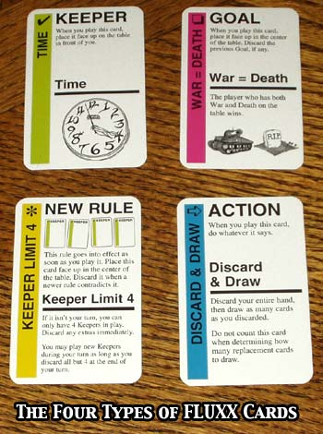

In some of them I want to put some graphics or formulas.

I tried with TikZ but had no luck (but I'm just a newbie). Can you help me?

(I plan to release it under a CC license.)

UPDATE: This is what I have:

\documentclass{minimal}

\usepackage[a4paper,margin=1cm]{geometry}

\usepackage{tikz}

\usepackage{multicol}

\usepackage{amsthm,amsmath,amssymb}

\usepackage[protrusion=true,expansion=true]{microtype}

\usetikzlibrary{positioning,shapes,shadows,arrows,backgrounds,fit}

\usepackage[utf8]{inputenc}

\begin{document}

\tikzstyle{textstyle}=[rectangle, text width=3.5cm, text badly ragged, scale=0.8]

\begin{multicols}{3}

\begin{center}

\begin{tikzpicture}[background rectangle/.style = {draw=black, fill=white,

rounded corners}, show background rectangle, node distance=0.3cm]

\node (side) [textstyle, fill=red, rotate=90, text width=4cm, scale=1.4, text centered] {%

\begin{tabular}{r}

TIME

\end{tabular}

};

\node (kind) [textstyle, right=of side, scale=1.5] {\textbf{KEEPER}};

\node (desckind) [textstyle, below=of kind] {

When you play this card, bla bla bla.

};

\node (title) [textstyle, below=of desckind, scale=1.3] {Time};

\node (separator) [thick, fill=black, below=of title, text width=3.5cm] {};

\node (description) [textstyle, below=of separator] {

The player bla bla bla bla

\[ H \Psi = \nabla \Psi \]

\[ J \Phi = \nabla \Phi \]

and then bla bla bla.

};

\end{tikzpicture}

\end{center}

\end{multicols}

\end{document}

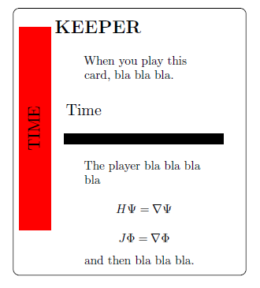

[tikz-pgf](https://tex.stackexchange.com/questions/tagged/tikz-pgf) [cards](https://tex.stackexchange.com/questions/tagged/cards)

[share](https://tex.stackexchange.com/q/47924)[improve this question](https://tex.stackexchange.com/posts/47924/edit)

[edited Mar 13 '12 at 23:40](https://tex.stackexchange.com/posts/47924/revisions)

[[https://www.gravatar.com/avatar/a65ec60b8080583b8f03557d39af0882?s=32&d=identicon&r=PG](https://tex.stackexchange.com/users/4012/doncherry)](https://tex.stackexchange.com/users/4012/doncherry)

[doncherry](https://tex.stackexchange.com/users/4012/doncherry)

34.6k23134208

asked Mar 13 '12 at 21:29

[[https://www.gravatar.com/avatar/a5f784a9929a5ee6dda7aa097c2e4fd8?s=32&d=identicon&r=PG](https://tex.stackexchange.com/users/1948/diego)](https://tex.stackexchange.com/users/1948/diego)

[Diego](https://tex.stackexchange.com/users/1948/diego)

540159

* 3

Can you show what you have tried so far, and exactly what you are having difficulty with? Is it the layout, the thick lines, the round edges, the larger font sizes, using colors? – [Peter Grill](https://tex.stackexchange.com/users/4301/peter-grill) [Mar 13 '12 at 21:42](https://tex.stackexchange.com/questions/47924/creating-playing-cards-using-tikz#comment98761_47924)

* @PeterGrill my greatest problem is the layout and fixing card sizes. – [Diego](https://tex.stackexchange.com/users/1948/diego) [Mar 13 '12 at 21:59](https://tex.stackexchange.com/questions/47924/creating-playing-cards-using-tikz#comment98763_47924)
* @Diego: Which problems have you solved yet? – [doncherry](https://tex.stackexchange.com/users/4012/doncherry) [Mar 13 '12 at 22:10](https://tex.stackexchange.com/questions/47924/creating-playing-cards-using-tikz#comment98765_47924)
* 2

Maybe ,this could be a good starting point for you: [tex.stackexchange.com/a/47165/9237](http://tex.stackexchange.com/a/47165/9237) – [Speravir](https://tex.stackexchange.com/users/9237/speravir) [Mar 13 '12 at 22:40](https://tex.stackexchange.com/questions/47924/creating-playing-cards-using-tikz#comment98770_47924)

* 3

Now I was just considering downvoting your question due to you littering the universe with yet another Fluxx version... 15 minutes of fun boiled down to 3 hours... OK, just kidding; but seriously: nice try, though you could choose an actually *good* game to do a variant of. Anyway, if you post your game on BGG, don't forget to mention TeX! – [mbork](https://tex.stackexchange.com/users/5626/mbork) [Mar 13 '12 at 23:55](https://tex.stackexchange.com/questions/47924/creating-playing-cards-using-tikz#comment98805_47924)

[show **3** more comments](https://tex.stackexchange.com/questions/47924/creating-playing-cards-using-tikz)

**4 Answers**

[active](https://tex.stackexchange.com/questions/47924/creating-playing-cards-using-tikz?answertab=active#tab-top) [oldest](https://tex.stackexchange.com/questions/47924/creating-playing-cards-using-tikz?answertab=oldest#tab-top) [votes](https://tex.stackexchange.com/questions/47924/creating-playing-cards-using-tikz?answertab=votes#tab-top)

up vote 61 down vote accepted

How about this 15-minute mockup (it's far from perfect, but quite ready to be turned into a reusable command):

\documentclass[parskip]{scrartcl}

\usepackage[margin=15mm]{geometry}

\usepackage{tikz}

\usepackage{pifont}

\begin{document}

\pgfmathsetmacro{\cardwidth}{5}

\pgfmathsetmacro{\cardheight}{8}

\newcommand{\stripcolor}{lime}

\pgfmathsetmacro{\stripwidth}{0.7}

\pgfmathsetmacro{\strippadding}{0.1}

\newcommand{\striptext}{INTER ARMA \ding{74}}

\pgfmathsetmacro{\textpadding}{0.3}

\newcommand{\topcaption}{LATIN}

\newcommand{\topcontent}{\textit{''Inter Arma Enim Silent Leges''}}

\newcommand{\bottomcaption}{Inter Arma}

\newcommand{\bottomcontent}{In times of war, the law falls silent.\\ \tikz{\fill[even odd rule] (0,0) circle (0.3) (-0.2,-0.2) rectangle (0.2,0.2);}}

\pgfmathsetmacro{\ruleheight}{0.3}

\begin{tikzpicture}

\draw[rounded corners=0.2cm] (0,0) rectangle (\cardwidth,\cardheight);

\fill[\stripcolor,rounded corners=0.1cm] (\strippadding,\strippadding) rectangle (\strippadding+\stripwidth,\cardheight-\strippadding) node[rotate=90,above left,black,font=\LARGE] {\striptext};

\node[text width=(\cardwidth-\strippadding-\stripwidth-2*\textpadding)*1cm,below right] at (\strippadding+\stripwidth+\textpadding,\cardheight-\textpadding)

{\LARGE \topcaption}\\

\topcontent\\

\tikz{\fill (0,0) rectangle (\cardwidth-\strippadding-\stripwidth-2*\textpadding,\ruleheight);}\\

{\LARGE \bottomcaption}\\

\bottomcontent\\

};

\end{tikzpicture}

\end{document}

I used the pifont package for the star symbol (\ding{74}). It has also the other symbols depicted in your photograph, have a look [here](http://willbenton.com/wb-images/pifont.pdf).

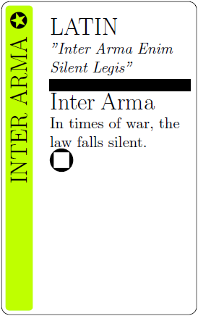

**Edit 1:** Now with a rotated symbol, and more options are set with keys:

\documentclass[parskip]{scrartcl}

\usepackage[margin=15mm]{geometry}

\usepackage{tikz}

\usepackage{pifont}

\usepackage{graphicx}

\begin{document}

\pgfmathsetmacro{\cardroundingradius}{4mm}

\pgfmathsetmacro{\striproundingradius}{3mm}

\pgfmathsetmacro{\cardwidth}{5}

\pgfmathsetmacro{\cardheight}{8}

\newcommand{\stripcolor}{cyan}

\pgfmathsetmacro{\stripwidth}{1.2}

\pgfmathsetmacro{\strippadding}{0.1}

\newcommand{\striptext}{INTER ARMA \rotatebox[origin=c]{-90}{\ding{49}}}

\pgfmathsetmacro{\textpadding}{0.3}

\newcommand{\topcaption}{LATIN}

\newcommand{\topcontent}{\textit{''Inter Arma Enim Silent Leges''}}

\newcommand{\bottomcaption}{Inter Arma}

\newcommand{\bottomcontent}{In times of war, the law falls silent.\\ \tikz{\fill[even odd rule] (0,0) circle (0.3) (-0.2,-0.2) rectangle (0.2,0.2);}}

\pgfmathsetmacro{\ruleheight}{0.1}

\newcommand{\stripfontsize}{\Huge}

\newcommand{\captionfontsize}{\LARGE}

\newcommand{\textfontsize}{\large}

\begin{tikzpicture}

\draw[rounded corners=\cardroundingradius] (0,0) rectangle (\cardwidth,\cardheight);

\fill[\stripcolor,rounded corners=\striproundingradius] (\strippadding,\strippadding) rectangle (\strippadding+\stripwidth,\cardheight-\strippadding) node[rotate=90,above left,black,font=\stripfontsize] {\striptext};

\node[text width=(\cardwidth-\strippadding-\stripwidth-2*\textpadding)*1cm,below right,inner sep=0] at (\strippadding+\stripwidth+\textpadding,\cardheight-\textpadding)

{ {\captionfontsize \topcaption}\\

{\textfontsize \topcontent}\\

\tikz{\fill (0,0) rectangle (\cardwidth-\strippadding-\stripwidth-2*\textpadding,\ruleheight);}\\

{\captionfontsize \bottomcaption}\\

{\textfontsize \bottomcontent}\\

};

\end{tikzpicture}

\end{document}

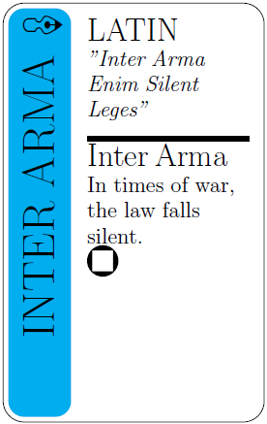

If the rotated symbol is too big, you may add some "don't size" modifier like \large inside the rotatebox before the \ding{n}.

[share](https://tex.stackexchange.com/a/47941)[improve this answer](https://tex.stackexchange.com/posts/47941/edit)

[edited Aug 1 '17 at 12:36](https://tex.stackexchange.com/posts/47941/revisions)

[[https://i.stack.imgur.com/Haz6W.jpg?s=32&g=1](https://tex.stackexchange.com/users/117218/glorfindel)](https://tex.stackexchange.com/users/117218/glorfindel)

[Glorfindel](https://tex.stackexchange.com/users/117218/glorfindel)

155119

answered Mar 13 '12 at 23:25

[[https://www.gravatar.com/avatar/15d96f5178d8bb06ae6f57046d9d95b7?s=32&d=identicon&r=PG](https://tex.stackexchange.com/users/7279/tom-bombadil)](https://tex.stackexchange.com/users/7279/tom-bombadil)

[Tom Bombadil](https://tex.stackexchange.com/users/7279/tom-bombadil)

34.7k8113170

* 3

+1 for Latin!!11 Feature request: Actually I want to upvote twice. But: Why “Legis”? Is there a philologic edition of Cicero with that reading? Cf. [en.wikipedia.org/wiki/Inter_arma_enim_silent_leges](http://en.wikipedia.org/wiki/Inter_arma_enim_silent_leges) – [Speravir](https://tex.stackexchange.com/users/9237/speravir) [Mar 14 '12 at 0:56](https://tex.stackexchange.com/questions/47924/creating-playing-cards-using-tikz#comment98816_47941)

* No, that's just a spelling mistake. I think I thought about "legislature", so *legis* felt more natural than *leges*. – [Tom Bombadil](https://tex.stackexchange.com/users/7279/tom-bombadil) [Mar 14 '12 at 7:05](https://tex.stackexchange.com/questions/47924/creating-playing-cards-using-tikz#comment98854_47941)
* @TomBombadil thank you! after tweaking it a bit, my only "problem" now is: how can I rotate the symbol? – [Diego](https://tex.stackexchange.com/users/1948/diego) [Mar 14 '12 at 9:54](https://tex.stackexchange.com/questions/47924/creating-playing-cards-using-tikz#comment98891_47941)
* @Diego: Go ahead and ask that as a new question. (You can link back to this question.) – [doncherry](https://tex.stackexchange.com/users/4012/doncherry) [Mar 14 '12 at 12:30](https://tex.stackexchange.com/questions/47924/creating-playing-cards-using-tikz#comment98919_47941)

• • @TomBombadil thank you for adding the rotation! – [Diego](https://tex.stackexchange.com/users/1948/diego) [Mar 14 '12 at 20:54](https://tex.stackexchange.com/questions/47924/creating-playing-cards-using-tikz#comment99066_47941)

[show **1** more comment](https://tex.stackexchange.com/questions/47924/creating-playing-cards-using-tikz)

up vote 90 down vote

+250

Based on the above answers I tried to create some kind of trading card game template with ti*k*z.

This is what the result looks like.

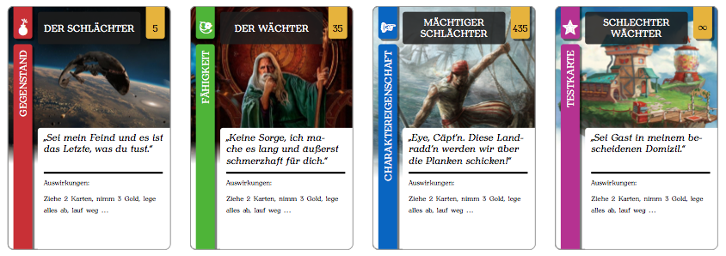

The images (out of the last one, so only the first three images) are just google searches. I hopefully don't upset anyone who owns these pictures. I only used them for testing purpose and to show you here.

For the cards' elements (like title box, price box etc.) I made new commands for simplifying usage. This is what to do for generating each card:

\begin{tikzpicture}

\cardbackground{img/illustration.jpg}

\cardtypeItem

\cardtitle{the card's title}

\cardcontent{fictitious quote for card character}{the card's effect, description or whatever comes to your mind}

\cardprice{5}

\cardborder

\end{tikzpicture}

As follows you can see my test scripts for a document with eight test cards. I'm sorry for not translating all my german contents and comments to english. too lazy for that right now. ;-)

**cards.tex**

\documentclass[a4paper,landscape]{article}

% Pakete dazuladen

\input{include/libs.tex}

% Farbdefinitionen laden

\input{include/colors.tex}

% \card-Commands laden

\input{include/tikzcards.tex}

% Dummy-Contents

\newcommand{\contentA}{Neunmalkluges Zitat\\mit Bezug zur Karte von einer fiktiven Figur.}

\newcommand{\contentB}{Auswirkungen:\\[5pt]Ziehe 2 Karten, nimm 3 Gold, lege alles ab, lauf weg …}

\begin{document}

\begin{center}

\pagestyle{empty}

% V-Space-Korrektur bei langen Titeln

% \cardtitle{\vspace{-5mm}SEHR LANGER TITEL}

\begin{tikzpicture}

\cardbackground{img/scifi.jpg}

\cardtypeItem

\cardtitle{Der Schlächter}

\cardcontent{Sei mein Feind und es ist das Letzte, was du tust.}{\contentB}

\cardprice{5}

\cardborder

% \carddebug

\end{tikzpicture}

\hspace{5mm}

\begin{tikzpicture}

\cardbackground{img/fantasy.jpg}

% \carddebug

\cardtypeAbility

\cardtitle{Der Wächter}

\cardcontent{Keine Sorge, ich mache es lang und äußerst schmerzhaft für dich.}{\contentB}

\cardprice{35}

\cardborder

\end{tikzpicture}

\hspace{5mm}

\begin{tikzpicture}

\cardbackground{img/pirate.jpg}

\cardtypeCharacter

\cardtitle{Mächtiger Schlächter}

\cardcontent{Eye, Cäpt'n. Diese Landradd'n werden wir über die Planken schicken!}{\contentB}

\cardprice{435}

\cardborder

\end{tikzpicture}

\hspace{5mm}

\begin{tikzpicture}

\cardbackground{img/moniuser.jpg}

\cardtypeTest

\cardtitle{Schlechter Wächter}

\cardcontent{Sei Gast in meinem bescheidenen Domizil.}{\contentB}

\cardprice{$\infty$}

\cardborder

\end{tikzpicture}

\vspace{5mm}

\begin{tikzpicture}

\cardbackground{img/cat.jpg}

\cardtypeItem

\cardtitle{Schmächtiger Wächter}

\cardcontent{Miau.}{\contentB}

\cardprice{5}

\cardborder

\end{tikzpicture}

\hspace{5mm}

\begin{tikzpicture}

\cardbackground{img/vb.png}

\cardtypeAbility

\cardtitle{Gebrechlicher Schlächter}

\cardcontent{\contentA}{\contentB}

\cardprice{35}

\cardborder

\end{tikzpicture}

\hspace{5mm}

\begin{tikzpicture}

\cardbackground{img/image.png}

\cardtypeCharacter

\cardtitle{Gerechter Wächter}

\cardcontent{\contentA}{\contentB}

\cardprice{435}

\cardborder

\end{tikzpicture}

\hspace{5mm}

\begin{tikzpicture}

\cardtypeTest

\cardtitle{Welcher Schlächter?}

\cardcontent{\contentA}{\contentB}

\cardprice{$\infty$}

\cardborder

\end{tikzpicture}

\end{document}

**libs.tex**

% VORAUSGESETZTE LIBS

% ------------------

% Ränder des Dokuments anpassen

\usepackage[margin=6mm,top=5mm]{geometry}

% Schriftart der auf den Karten eingesetzten Texte

\usepackage{anttor}

% UTF-8 Encoding der TeX-Dateien

\usepackage[utf8]{inputenc}

% deutsches Sprachpaket

\usepackage[german]{babel}

% optischer Randausgleich

\usepackage{microtype}

% Einbinden von Grafiken

\usepackage{graphicx}

% Definieren und Verwenden von Farben

\usepackage{color}

% TikZ zum "Malen" von Grafiken, in diesem Falle für die Karten

\usepackage{tikz}

\usetikzlibrary{patterns}

\usetikzlibrary{shadows}

% Symbole dazuladen; Verwendung \ding{<nummer>}

\usepackage{pifont}

% weitere Symbole

\usepackage{fourier-orns}

**colors.tex**

% FARBEN DER ELEMENTE/BESTANDTEILE DER KARTEN

% -----------------------------------------

% Hintergrundfarbe für den Titel-Kasten

\definecolor{titlebg}{RGB}{30,30,30}

% Farben der "Fähnchen" zur Kennzeichnung der unterschiedlichen Kartentypen

\definecolor{characterbg}{RGB}{0,100,200}

\definecolor{abilitybg}{RGB}{80,180,0}

\definecolor{itembg}{RGB}{200,50,50}

\definecolor{testbg}{RGB}{180,50,150}

% Farbe des "Fähnchens" zur Angabe des Preises der Karten

\definecolor{pricebg}{RGB}{230,180,0}

% Hintergrundfarbe für den Textbereich

%\definecolor{content}{RGB}{250,250,245}

\definecolor{contentbg}{RGB}{255,255,255}

and now the most interesting file for you i guess…

**tikzcards.tex**

% COMMANDS ZUM ZUSAMMENBAUEN DER KARTEN

% ---------------------------------------

% TikZ/PGF Settings für die Karten

\pgfmathsetmacro{\cardwidth}{6}

\pgfmathsetmacro{\cardheight}{9}

\pgfmathsetmacro{\imagewidth}{\cardwidth}

\pgfmathsetmacro{\imageheight}{0.75*\cardheight}

\pgfmathsetmacro{\stripwidth}{0.7}

\pgfmathsetmacro{\strippadding}{0.2}

\pgfmathsetmacro{\textpadding}{0.1}

\pgfmathsetmacro{\titley}{\cardheight-\strippadding-1.5*\textpadding-0.5*\stripwidth}

% Formen der einzelnen Kartenelemente/-bestandteile

\def\shapeCard{(0,0) rectangle (\cardwidth,\cardheight)}

\def\shapeLeftStripLong{(\strippadding,-0.2) rectangle (\strippadding+\stripwidth,\cardheight-\strippadding-\strippadding-1)}

\def\shapeLeftStripShort{(\strippadding,\cardheight-\strippadding-1) rectangle (\strippadding+\stripwidth,\cardheight+0.2)}

\def\shapeRightStripShort{(\cardwidth-\stripwidth-\strippadding,\cardheight-\strippadding-1) rectangle (\cardwidth-\strippadding,\cardheight+0.2)}

\def\shapeTitleArea{(2*\strippadding+\stripwidth,\cardheight-\strippadding) rectangle (\cardwidth-2*\strippadding-\stripwidth,\cardheight-2*\stripwidth)}

\def\shapeContentArea{(2*\strippadding+\stripwidth,0.5*\cardheight) rectangle (\cardwidth+0.2,-0.2)}

% Stylings für die Elemente definieren

\tikzset{

% runde Ecken für die Karten

cardcorners/.style={

rounded corners=0.2cm

},

% runde Ecken für die "Fähnchen"

elementcorners/.style={

rounded corners=0.1cm

},

% Schlagschatten für die "Fähnchen"

stripshadow/.style={

drop shadow={

opacity=.5,

shadow,

color=black

}

},

% Style für die "Fähnchen"

strip/.style={

elementcorners,

stripshadow

},

% Bild für das Kartenmotiv

cardimage/.style={

path picture={

\node[below=-1.5mm] at (0.5*\cardwidth,\cardheight) {

\includegraphics[width=\imagewidth cm]{#1}

};

}

},

}

% TikZ-Raster

\newcommand{\carddebug}{

\draw [step=1,help lines] (0,0) grid (\cardwidth,\cardheight);

}

% Rahmen der Karte

\newcommand{\cardborder}{

\draw[lightgray,cardcorners] \shapeCard;

}

% Hintergrund der Karte

\newcommand{\cardbackground}[1]{

\draw[cardcorners, cardimage=#1] \shapeCard;

}

% Kategorie der Karte

\newcommand{\cardtype}[3]{

% First we fill the intersecting area

% The \clip command does not allow options, therefore

% we have to use a scope to set the even odd rule.

\begin{scope}[even odd rule]

% Define a clipping path. All paths outside shapeCard will

% be cut because the even odd rule is set.

\clip[cardcorners] \shapeCard;

% Fill shapeLeftStripLong and shapeLeftStripShort.

% Since the even odd rule is set, only the card will be filled.

\fill[strip,#1] \shapeLeftStripLong node[rotate=90,above left=0.9mm,font=\normalsize] {

\color{white}\uppercase{#2}

};

\fill[strip,#1] \shapeLeftStripShort;

\end{scope}

\node at (\strippadding+\stripwidth-0.28,\cardheight-\strippadding-\strippadding-0.37) {\color{white}#3};

}

\newcommand{\cardtypeCharacter}{\cardtype{characterbg}{Charaktereigenschaft}{\hspace{-1mm}\LARGE\lefthand}}

\newcommand{\cardtypeAbility}{\cardtype{abilitybg}{Fähigkeit}{\hspace{-1mm}\Large\floweroneright}}

\newcommand{\cardtypeItem}{\cardtype{itembg}{Gegenstand}{\hspace{-1mm}\LARGE\bomb}}

\newcommand{\cardtypeTest}{\cardtype{testbg}{Testkarte}{\hspace{-1.4mm}\huge\ding{78}}}

% Titel der Karte

\newcommand{\cardtitle}[1]{

%\draw[pattern=soft crosshatch,rounded corners=0.1cm] \shapeTitleArea;

\fill[elementcorners,titlebg,opacity=.85] \shapeTitleArea;

\node[text width=3.75cm] at (0.5*\cardwidth,\titley) {

\begin{center}

\color{white}\uppercase{\normalsize #1}

\end{center}

};

}

% Inhalt der Karte

\newcommand{\cardcontent}[2]{

\begin{scope}[even odd rule]

\clip[cardcorners] \shapeCard;

\fill[elementcorners,contentbg] \shapeContentArea;

\end{scope}

\node[below right, text width=(\cardwidth-2*\strippadding-\stripwidth-2*\textpadding-0.3)*1cm] at (2*\strippadding+\stripwidth+\textpadding,0.5*\cardheight-\textpadding) {

\textit{\glqq\normalsize #1\grqq}

};

\node[below right, text width=(\cardwidth-2*\strippadding-\stripwidth-2*\textpadding-0.3)*1cm] at (2*\strippadding+\stripwidth+\textpadding,3) {

\vrule width \textwidth height 2pt \\[-2pt]

\vspace{0.2cm}

{\scriptsize #2}

};

}

% Preis der Karte

\newcommand{\cardprice}[1]{

\begin{scope}[even odd rule]

\clip[cardcorners] \shapeCard;

\fill[strip,pricebg] \shapeRightStripShort;

\end{scope}

\node at (\cardwidth-0.5*\stripwidth-\strippadding,\titley-0.1) {\color{black}#1};

}

Now you only have to include the missing background images for your cards and correct the file paths. I won't upload those. ;-)

Here another example:

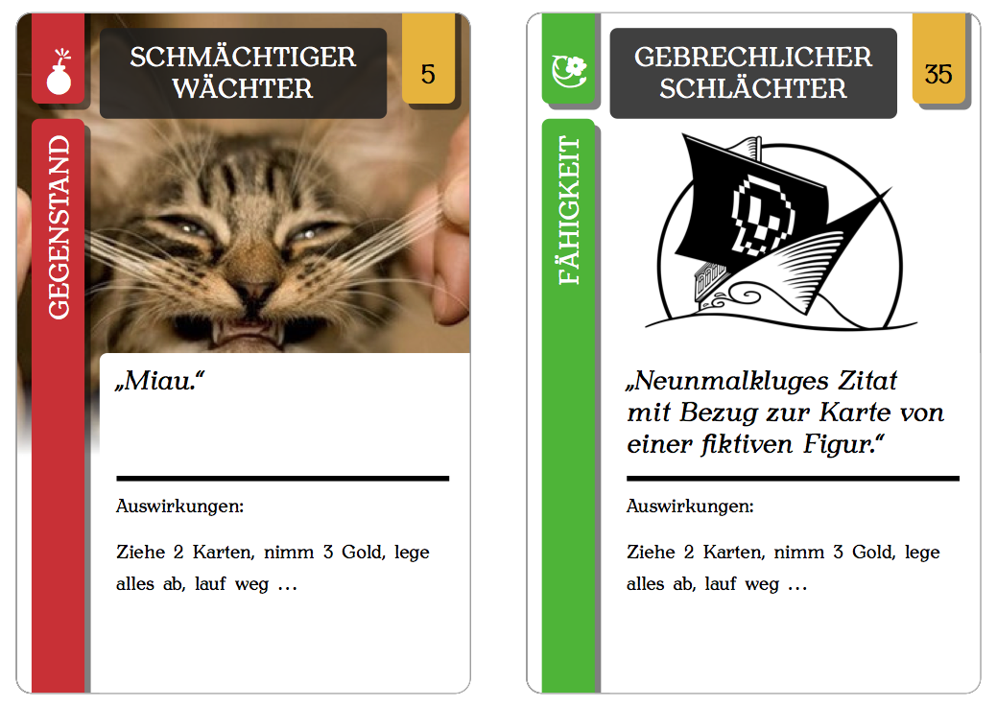

Hope you enjoy my template. Feel free to use it for whatever you want. **Thanks to the others who answered above and helped out with some code snippets and stuff! My template is your legacy. ;-)**

[share](https://tex.stackexchange.com/a/185830)[improve this answer](https://tex.stackexchange.com/posts/185830/edit)

[edited Jun 15 at 19:43](https://tex.stackexchange.com/posts/185830/revisions)

[[https://www.gravatar.com/avatar/f472fce23bfc518d4088095646989ba4?s=32&d=identicon&r=PG&f=1](https://tex.stackexchange.com/users/123129/dexteritas)](https://tex.stackexchange.com/users/123129/dexteritas)

[dexteritas](https://tex.stackexchange.com/users/123129/dexteritas)

3,417726

answered Jun 20 '14 at 18:24

[[https://www.gravatar.com/avatar/a1c8fe12f061183f709eb9fc58be3dc5?s=32&d=identicon&r=PG](https://tex.stackexchange.com/users/55952/arvid)](https://tex.stackexchange.com/users/55952/arvid)

[Arvid](https://tex.stackexchange.com/users/55952/arvid)

1,268610

* 5

Have you thought about turning this into a package? – [Gaussler](https://tex.stackexchange.com/users/19809/gaussler) [Nov 11 '15 at 12:00](https://tex.stackexchange.com/questions/47924/creating-playing-cards-using-tikz#comment668779_185830)

* 3

Not yet. But I indeed thought of making a GitHub or Bitbucket project to make it easier for all of you guys to access and also commit changes to the TeX code above. By the way I (almost) completely re-built the template for a card game I am working on for a while now. (Unfortunately no prgress to show here or anywhere else since I work to much on "real" projects I get paid for and so I can't finish my game… But its code base is even better than the one above! ;)) – [Arvid](https://tex.stackexchange.com/users/55952/arvid) [Nov 11 '15 at 16:46](https://tex.stackexchange.com/questions/47924/creating-playing-cards-using-tikz#comment668891_185830)

* 2

as for the opacity problem.. removing the whitespace before 'opacity' solved it for me.. I think perhaps the copy paste introduces an invisible but non-space character.. – [Born2Smile](https://tex.stackexchange.com/users/23075/born2smile) [Aug 9 '16 at 3:15](https://tex.stackexchange.com/questions/47924/creating-playing-cards-using-tikz#comment791060_185830)

* 2

@Arvid No problem - great job, so wanted to contribute somehow. There's still one more thing: drop shadow={ opacity=.5, shadow, color=black } I had to delete the second occurrence of "shadow" to make it work. However, I don't know LaTeX well enough in order to say if that's an issue that's local only to my machine. – [Alojzy Leszcz](https://tex.stackexchange.com/users/125651/alojzy-leszcz) [Mar 3 '17 at 14:52](https://tex.stackexchange.com/questions/47924/creating-playing-cards-using-tikz#comment878239_185830)

* 2

Very nice template indeed! I've used it to make my own "Timeline-like" deck of cards [github.com/romulusFR/timeline_informatique](https://github.com/romulusFR/timeline_informatique) – [Romuald](https://tex.stackexchange.com/users/25966/romuald) [Aug 24 '17 at 9:39](https://tex.stackexchange.com/questions/47924/creating-playing-cards-using-tikz#comment961994_185830)

[show **11** more comments](https://tex.stackexchange.com/questions/47924/creating-playing-cards-using-tikz)

up vote 8 down vote

(Just saw Tom's answer, but since I had begun writing, I'm gonna finish anyways.)

This is a) too long to be a comment and b) an answer without code, perhaps you can translate some of what I'm saying into code yourself or look up how to do it.

Thank you for adding the code, this looks pretty good! I hardly know any TikZ, so I can't tell you what to change in your code, but here are some ideas about the layout:

* (Not layout-related, actually) [Don't use minimal as a document class](https://tex.stackexchange.com/q/42114/4012). Using article instead will get rid of the warnings for you.
* The real card corners are more rounded, i.e. there's more "cut off".
* The side ratio of your card is off, they need to be higher (something like width 3 to height 4). An easy way to fix this is increasing the height of the colored box.
* The text in the colored box actually is right-aligned and bigger; and it is a sans-serif font, just like the other title-y parts.
* The "Time" above the black bar needs to be bigger.
* The colored box needs to extend all the way to the top, just as far as it goes to the bottom.
* After all, adding more text and perhaps a little image will get you closer to the model.

Generally, it's good to break up your problem into tiny parts like these. Then, you can search for something really specific in our question base or in the manual, and ask about it if you couldn't find anything.

[share](https://tex.stackexchange.com/a/47942)[improve this answer](https://tex.stackexchange.com/posts/47942/edit)

[edited Apr 13 '17 at 12:34](https://tex.stackexchange.com/posts/47942/revisions)

[[https://www.gravatar.com/avatar/a007be5a61f6aa8f3e85ae2fc18dd66e?s=32&d=identicon&r=PG](https://tex.stackexchange.com/users/-1/community)](https://tex.stackexchange.com/users/-1/community)

[Community](https://tex.stackexchange.com/users/-1/community)♦

1

answered Mar 13 '12 at 23:37

[[https://www.gravatar.com/avatar/a65ec60b8080583b8f03557d39af0882?s=32&d=identicon&r=PG](https://tex.stackexchange.com/users/4012/doncherry)](https://tex.stackexchange.com/users/4012/doncherry)

[doncherry](https://tex.stackexchange.com/users/4012/doncherry)

34.6k23134208

add a comment

up vote 6 down vote

*Update on Arvid's template posted above*

If one copy pastes everything, a lot of warnings pop up Just hit s+Enter keys to enter scrollmode.

* A black box is showing in the content area. To solve this comment the following line in **tikzcards.tex**
* \def\shapeContentArea{(2*\strippadding+\stripwidth,0.5*\cardheight)

rectangle (\cardwidth+0.2,-0.2)}

* The symbols are not showing up on the top left Add the fourier package in **libs.tex**

\usepackage{fourier}

[share](https://tex.stackexchange.com/a/289561)[improve this answer](https://tex.stackexchange.com/posts/289561/edit)

[edited Oct 4 '16 at 23:43](https://tex.stackexchange.com/posts/289561/revisions)

answered Jan 26 '16 at 21:22

[[https://www.gravatar.com/avatar/de631e9fe926fcf1663c8419c7d8fbbb?s=32&d=identicon&r=PG&f=1](https://tex.stackexchange.com/users/96818/georges)](https://tex.stackexchange.com/users/96818/georges)

[Georges](https://tex.stackexchange.com/users/96818/georges)

356415

* 2

This should be a comment to [Arvid's answer](http://tex.stackexchange.com/a/185830/5764)... – [Werner](https://tex.stackexchange.com/users/5764/werner) [Jan 26 '16 at 21:46](https://tex.stackexchange.com/questions/47924/creating-playing-cards-using-tikz#comment700637_289561)

* 1

i just signed up so not enough reputation.. sorry – [Georges](https://tex.stackexchange.com/users/96818/georges) [Jan 26 '16 at 21:48](https://tex.stackexchange.com/questions/47924/creating-playing-cards-using-tikz#comment700640_289561)

* 2

Thanks for figuring out. I don't have enough time for that, so I'm glad others do my work. ;) Have fun with my up-vote. :) – [Arvid](https://tex.stackexchange.com/users/55952/arvid) [Jun 9 '16 at 19:39](https://tex.stackexchange.com/questions/47924/creating-playing-cards-using-tikz#comment765592_289561)

* 2

Actually created a whole new game with your tex, more info coming soon :) – [Georges](https://tex.stackexchange.com/users/96818/georges) [Jun 14 '16 at 18:20](https://tex.stackexchange.com/questions/47924/creating-playing-cards-using-tikz#comment767857_289561)

* 3

an amino acids card game! bit.ly/cards101 – [Georges](https://tex.stackexchange.com/users/96818/georges) [Jun 22 '16 at 18:46](https://tex.stackexchange.com/questions/47924/creating-playing-cards-using-tikz#comment771476_289561)

[show **1** more comment](https://tex.stackexchange.com/questions/47924/creating-playing-cards-using-tikz)